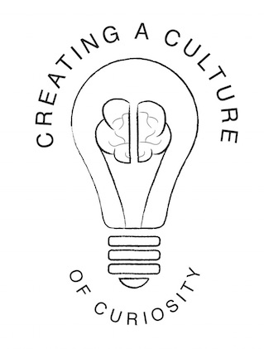
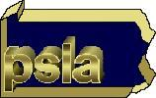
Pennsylvania School Librarians Association
44th Annual Conference – March 30-April 1, 2017
Hershey Lodge and Convention Center
“Creating a Culture of Curiosity”
The 2017 Pennsylvania School Librarians Association Conference Committee invites everyone to share their best ideas and work with the library community by presenting a poster session at our Exploratorium in Hershey, Pennsylvania on Thursday, March 30, 2017 in the Hershey Lodge and Convention Center Exhibit Hall.
Submissions are invited from all libraries on any topic relevant to our conference theme: Creating a Culture of Curiosity.
Posters may include a description of innovative library lessons or programs; an analysis of a solution to a problem; a report of a research study; or any other presentation that would benefit the larger library community. Poster session participants populate boards with pictures, data, graphs, diagrams, narrative text and more and informally discuss their presentations with conference attendees during a one-hour time period. Consider bringing other colleagues or students to help present and share your information.
For information on 2017 posters and the submission process, please visit http://pslaconference.weebly.com/exploratorium.html
Presenters must be registered to attend at least the exhibits portion of the PSLA Conference in March. The deadline for applying is February 10, 2017. Applicants will be notified by the end of February if their submission has been accepted for presentation at the conference. Start your application process now by completing the form below.
Please submit your application, and direct any questions about Exploratorium poster session presentations to Jane Farrell, Exploratorium Subcommittee Chair, jane.farrell@dallastown.net,
2017 PSLA Annual Conference, Hershey, PA, March 30 – April 1.
Name of Presenter
Additional Presenters
Title
School District
Topic of Poster—please briefly explain.
Contact Information

